DAY-1

1. 28 html

  <!DOCTYPE html>

<html lang="en">

<head>

    <meta charset="UTF-8">

    <meta name="viewport" content="width=device-width, initial-scale=1.0">

    <title>Nested Webpage</title>

    <style>

        body {

            font-family: Arial, sans-serif;

            margin: 0;

            padding: 0;

            display: flex;

            justify-content: center;

            align-items: center;

            height: 100vh;

            background-color: #f0f0f0;

        }

        .container {

            width: 80%;

            height: 80%;

            background-color: #fff;

            box-shadow: 0 0 10px rgba(0, 0, 0, 0.1);

            display: grid;

            grid-template-areas:

                "A B"

                "C C";

            grid-template-rows: auto auto;

            grid-template-columns: 1fr 1fr;

            gap: 20px;

            padding: 20px;

        }

        .block {

            display: flex;

            justify-content: center;

            align-items: center;

            font-size: 2em;

            color: white;

            font-weight: bold;

            height: 150px;

        }

        .block-a {

            background-color: purple;

            grid-area: A;

        }

        .block-b {

            background-color: orange;

            grid-area: B;

        }

        .block-c {

            background-color: blue;

            grid-area: C;

        }

    </style>

</head>

<body>

    <div class="container">

        <div class="block block-a">A</div>

        <div class="block block-b">B</div>

        <div class="block block-c">C</div>

    </div>

</body>

</html>

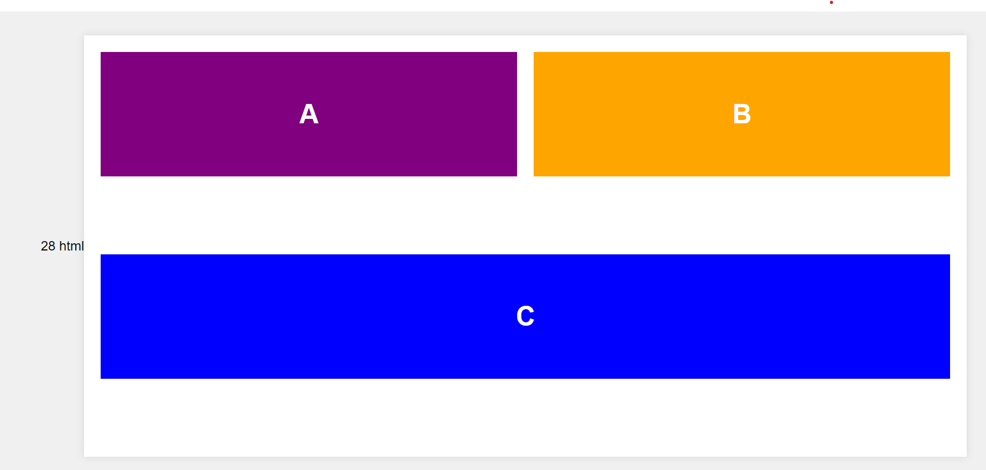

1. <!DOCTYPE html>

<html lang="en">

<head>

<meta charset="UTF-8">

<meta name="viewport" content="width=device-width, initial-scale=1.0">

<title>Headings Example</title>

</head>

<body>

<h1>This is a Heading 1</h1>

<h2>This is a Heading 2</h2>

<h3>This is a Heading 3</h3>

<h4>This is a Heading 4</h4>

<h5>This is a Heading 5</h5>

<h6>This is a Heading 6</h6>

<p>This is a normal paragraph text. Compare the fonts used for the various headings with the default font used for paragraph text.</p>

</body>

</html>

3. <!DOCTYPE html>

<html lang="en">

<head>

<meta charset="UTF-8">

<meta name="viewport" content="width=device-width, initial-scale=1.0">

<title>Bike Showroom</title>

<style>

body {

font-family: Arial, sans-serif;

margin: 0;

padding: 0;

display: flex;

justify-content: center;

align-items: center;

height: 100vh;

background-color: #f0f0f0;

}

.container {

display: grid;

grid-template-areas:

"header header"

"left top"

"left right";

grid-template-rows: auto 1fr 1fr;

grid-template-columns: 1fr 1fr;

gap: 10px;

width: 90%;

height: 90%;

background-color: #fff;

box-shadow: 0 0 10px rgba(0, 0, 0, 0.1);

padding: 20px;

}

.header {

grid-area: header;

background-color: #333;

color: white;

text-align: center;

padding: 20px;

font-size: 24px;

}

.left {

grid-area: left;

background-color: #e0e0e0;

padding: 10px;

}

.top {

grid-area: top;

background-color: #d0d0d0;

padding: 10px;

text-align: center;

}

.right {

grid-area: right;

background-color: #c0c0c0;

padding: 10px;

display: flex;

flex-direction: column;

align-items: center;

justify-content: center;

}

.bike-image {

max-width: 100%;

height: auto;

}

.bike-brand {

margin: 10px 0;

}

</style>

</head>

<body>

<div class="container">

<header class="header">Bike Showroom</header>

<aside class="left">

<h2>Brands</h2>

<ul>

<li><a href="#brand1">Brand 1</a></li>

<li><a href="#brand2">Brand 2</a></li>

<li><a href="#brand3">Brand 3</a></li>

<li><a href="#brand4">Brand 4</a></li>

</ul>

</aside>

<div class="top" id="showroom-name">

<h2>Welcome to Our Showroom</h2>

<p>Your one-stop destination for premium bikes.</p>

</div>

<div class="right">

<div class="bike-brand" id="brand1">

<h3>Brand 1</h3>

<img src="https://encrypted-tbn0.gstatic.com/images?q=tbn:ANd9GcReLvSkj4FgbgQ3_Nw1V_3NW54OqJFa-9AoMA&s" alt="Brand 1 Bike" class="bike-image">

<p>Model: Speedster</p>

<p>Specifications: High-speed, lightweight, durable.</p>

</div>

<div class="bike-brand" id="brand2">

<h3>Brand 2</h3>

<img src="https://encrypted-tbn0.gstatic.com/images?q=tbn:ANd9GcQmcCgo40bd4cvf54sRCZ-5QSjnap99x0thWA&s" alt="Brand 2 Bike" class="bike-image">

<p>Model: Cruiser</p>

<p>Specifications: Comfortable, stylish, smooth ride.</p>

</div>

<div class="bike-brand" id="brand3">

<h3>Brand 3</h3>

<img src="https://encrypted-tbn0.gstatic.com/images?q=tbn:ANd9GcRqfyAwndfN0E2I38Y2UF6nCzCF6NfM_OFVVg&s" alt="Brand 3 Bike" class="bike-image">

<p>Model: Mountain</p>

<p>Specifications: Off-road, robust, high endurance.</p>

</div>

<div class="bike-brand" id="brand4">

<h3>Brand 4</h3>

<img src="https://encrypted-tbn0.gstatic.com/images?q=tbn:ANd9GcSotcOXZwyyZfCxVJRjUiK2o26PiaQZcSR7hA&s" alt="Brand 4 Bike" class="bike-image">

<p>Model: City</p>

<p>Specifications: Urban, compact, fuel-efficient.</p>

</div>

</div>

</div>

</body>

</html>

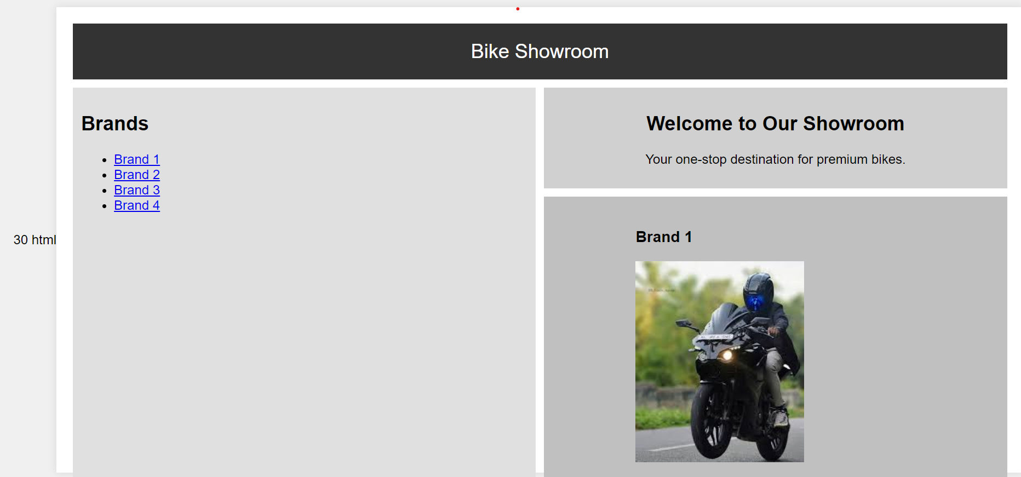

4. Italian flag

<!DOCTYPE html>

<html lang="en">

<head>

    <meta charset="UTF-8">

    <meta name="viewport" content="width=device-width, initial-scale=1.0">

    <title>Italian Flag</title>

    <link rel="stylesheet" href="styles.css">

</head>

<body>

    <div class="flag-container">

        <div class="green"></div>

        <div class="white"></div>

        <div class="red"></div>

    </div>

</body>

</html>

5. <!DOCTYPE html>

<html lang="en">

<head>

    <meta charset="UTF-8">

    <meta name="viewport" content="width=device-width, initial-scale=1.0">

    <title>Nested Webpage</title>

    <link rel="stylesheet" href="nested-styles.css">

</head>

<body>

    <div class="container">

        <header class="header">Header</header>

        <nav class="navbar">Navigation Bar</nav>

        <main class="main-content">

            <iframe src="https://www.example.com" title="Nested Page" class="nested-frame"></iframe>

        </main>

        <aside class="sidebar">Sidebar</aside>

        <footer class="footer">Footer</footer>

    </div>

</body>

</html>

